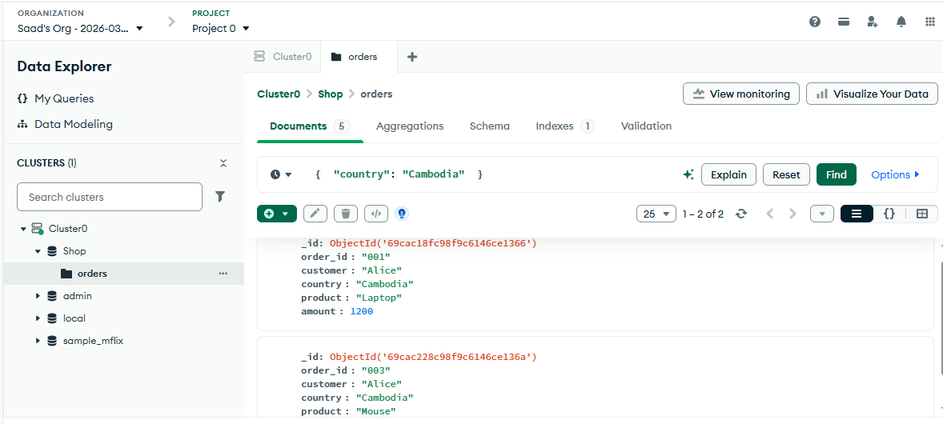
Query 1 Find all orders from Cambodia

Query 2 Find orders where amount > 500
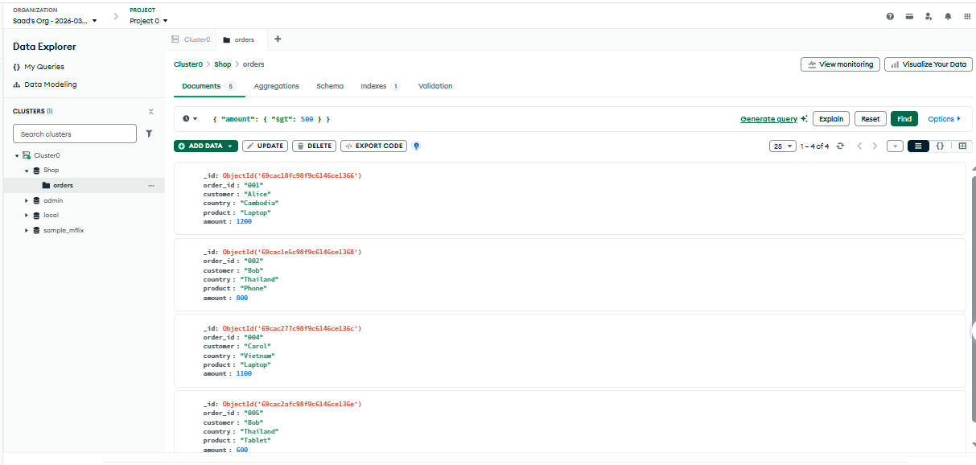

Query 3 Show only customer and product
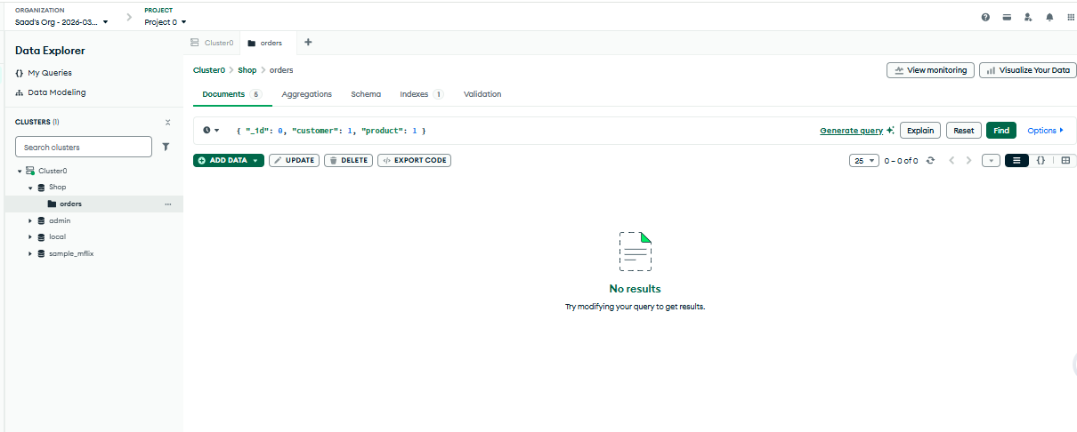

QUERY 4 — Update Bob’s Phone amount
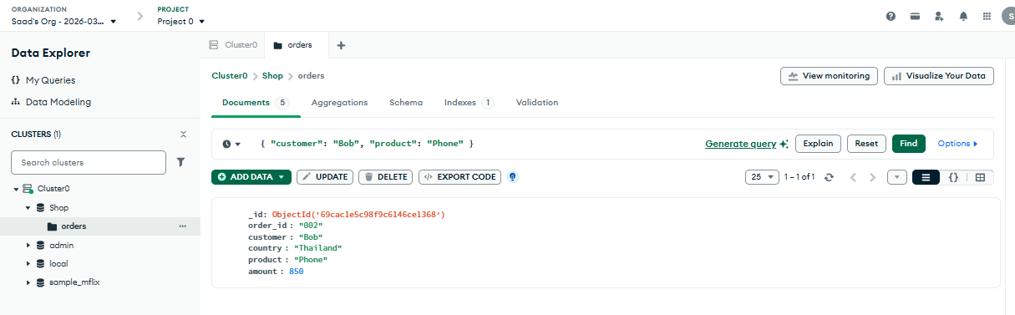
Query 5 Verify the update
